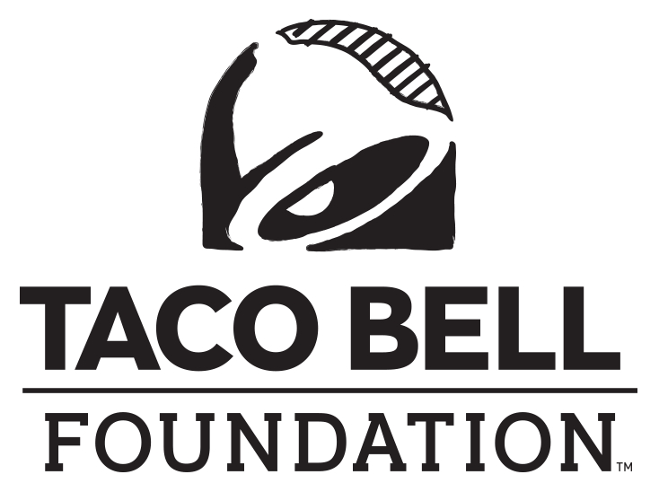

FOR IMMEDIATE RELEASE

MEDIA CONTACT:

Sydney Cerri

Becker Communications, Inc.

[sydney@beckercommunications.com](mailto:sydney@beckercommunications.com)

**TWO LOCAL NONPROFITs RECEIVE GRANTS**

**TO EMPOWER HAWAII’S YOUTH**

**HONOLULU (July 9, 2024)** – Helping to empower Hawaii’s youth, **the Taco Bell Foundation** recently awarded grants to two local nonprofit organizations: $30,000 to **Boys & Girls Club of Hawaii** and $17,200 to **Junior Achievement of Hawaii**. These funds will benefit over 10,000 young individuals in local communities by supporting initiatives focused on character and leadership development, educational and career advancement, health and life skills, and various other programs designed to inspire the future leaders of tomorrow.

“It’s especially fulfilling to see the direct impact these grants will have on our youth,” said Kevin Kurihara, President of TD Food Group, Inc. “By partnering with the Taco Bell Foundation, we are not only supporting educational and leadership opportunities but also nurturing the dreams and aspirations of the next generation.”

The Boys & Girls Club of Hawaii and Junior Achievement of Hawaii join more than 400 youth-focused organizations that will receive a share of $15 million in Community Grants distributed by the Taco Bell Foundation this year. These grants highlight the Foundation's commitment to dismantling educational obstacles and nurturing the bold ambitions of young people.

"We take pride in our Community Grants program, which provides young individuals with the essential resources and opportunities to learn and drive positive change,” said Jennifer Bradbury, Executive Director of the Taco Bell Foundation.

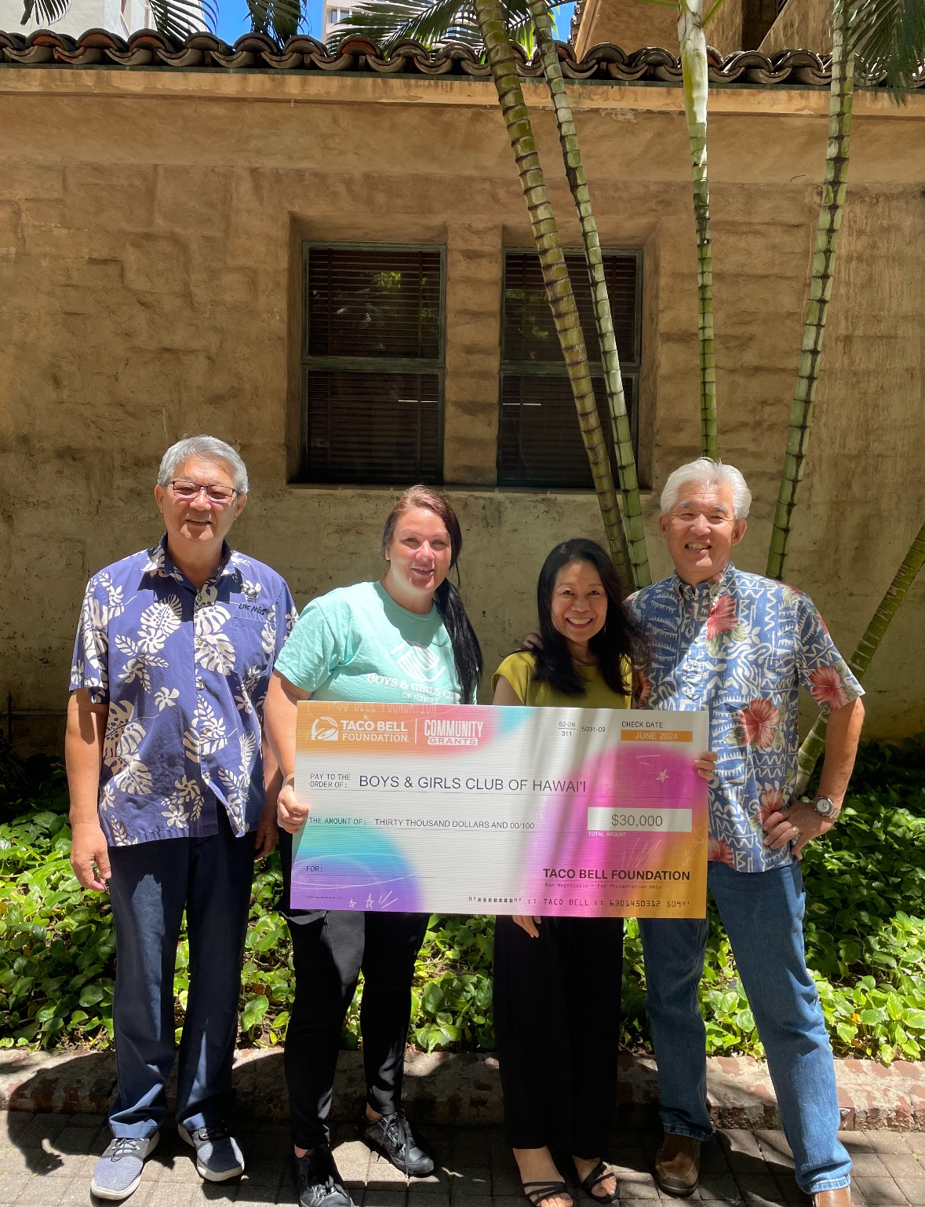

Boys & Girls Club of Hawaii Check Presentation (left to right): *Yong Min Kim, Operations Director, TD Food Group, Inc.; Inglish Jones, Director of Development, Boys & Girls Club of Hawaii; Leah Allen, Marketing Director, TD Food Group, Inc.; and Brent Matsumoto, Vice President, TD Food Group, Inc.*

***About the Taco Bell Foundation***

**Taco Bell Foundation**, Inc. is a 501(c)(3) tax-exempt public charity that educates and inspires the next generation of leaders through programming like the Live Más Scholarship and the Local Grants Program. Since 1992, the Taco Bell Foundation has reached more than 5 million young people across the country and has awarded more than $150 million in grants and scholarships, focused on education and career readiness. In 2015, Taco Bell and the Taco Bell Foundation launched the [Live Más Scholarship](https://www.tacobellfoundation.org/live-mas-scholarship/), a program aimed at fueling the bold ambitions of America’s future leaders. In May 2023, the Taco Bell Foundation awarded $10 million in Live Más Scholarships to over 900 students. For more information, visit [TacoBellFoundation.org.](http://www.tacobellfoundation.org/)

***About TD Food Group***

TD Food Group operates 59 Pizza Hut and Taco Bell restaurants throughout the Hawaiian Islands and 13 Pizza Hut and Taco Bell restaurants in Guam and Saipan.

###