FOR IMMEDIATE RELEASE MEDIA CONTACTS:

Caroline Witherspoon or

Sydney Cerri

Becker Communications, Inc.

(808) 533-4165

**TACO BELL FOUNDATION AWARDS HAWAII EMPLOYEE WITH**

**LIVE MÁS SCHOLARSHIP FOR HIGHER EDUCATION**

HONOLULU (XX) – The Taco Bell Foundation recently awarded one Hawaii Taco Bell employee with the Live Más Scholarship to pursue higher education. **Catalina Naki-Alforte**, a Team Member at Taco Bell Nanakuli, received a $10,000 scholarship.

Naki-Alforte plans to use her Live Más Scholarship at University of Hawai’i to pursue a career in law enforcement. This year, the Taco Bell Foundation awarded $2.8 million in Live Más Scholarships to 280 Taco Bell Team Members across the country.

The Live Más Scholarship was designed to support students aged 16-26 passionate about creating a better future and positively impacting their community. Scholarships range from $5,000 to $25,000 per student. In addition to financial support, the Taco Bell Foundation gives recipients access to connections and opportunities to gain the most impactful experiences.

**About Taco Bell Foundation**

Taco Bell Foundation, Inc. is a 501(c)(3) public charity that helps America's young people pursue their educational goals and career aspirations. Since 1992, the Foundation has reached more than 4 million youth across the country and has awarded more than $110 million in Live Más Scholarships and grants, focused on education and career readiness. For more information about the Taco Bell Foundation, visit [www.tacobellfoundation.org](http://www.tacobellfoundation.org/).

**About TD Food Group**

TD Food Group operates 57 Pizza Hut and Taco Bell restaurants throughout the Hawaiian Islands and 13 Pizza Hut and Taco Bell restaurants in Guam and Saipan.

# # #

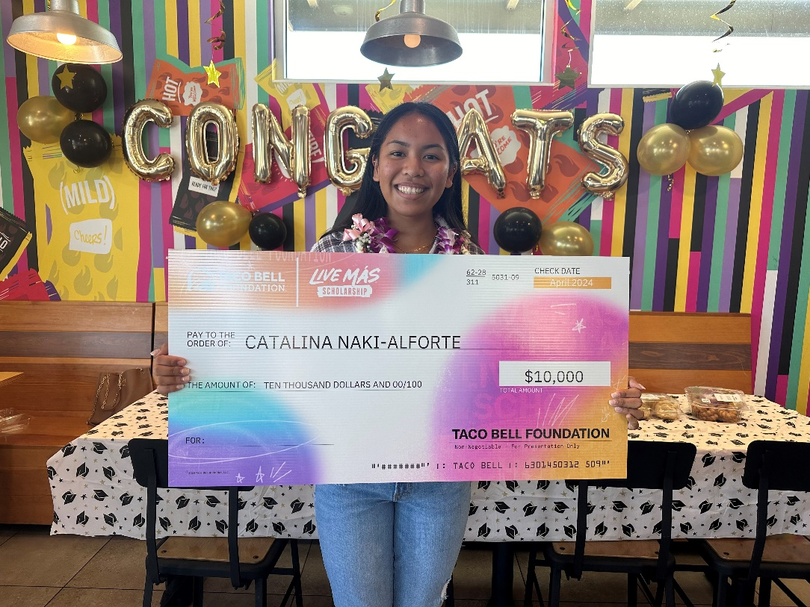

*Pictured: Catalina Naki-Alforte, 2024 Live Mas Scholarship Award Winner*

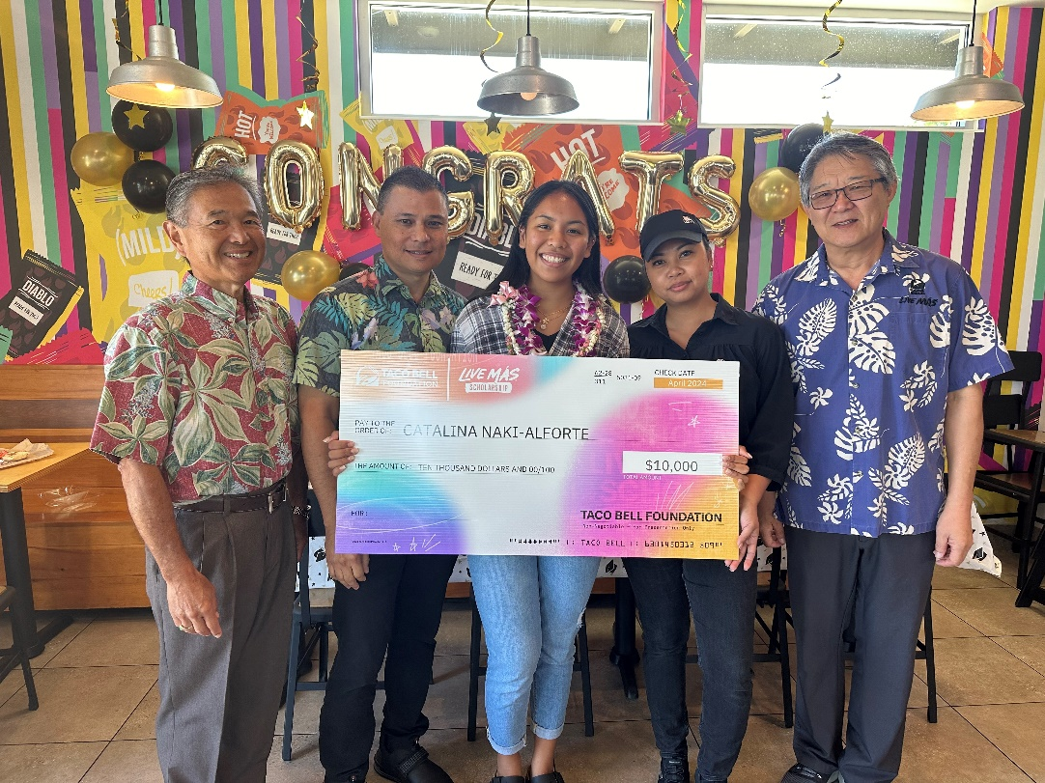

*Pictured (from left to right): Kevin Kurihara, Duane Kaplan, Catalina Naki-Alforte, Larmie Agmata, and Yong Min Kim*