**EWA BEACH PIZZA HUT AND TACO BELL GRAND OPENING**

**November 30, 2023**

 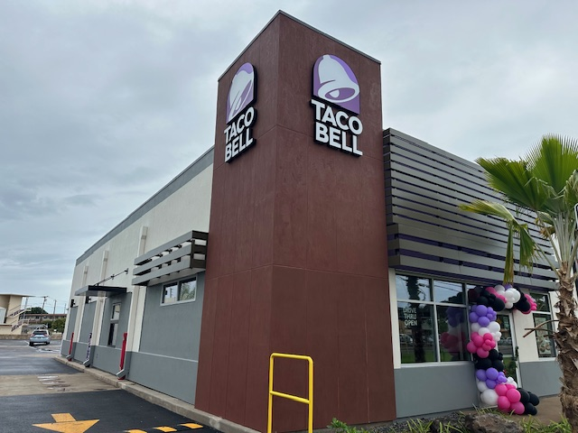

On November 30, Pizza Hut Hawaii and Taco Bell Hawaii opened its newly renovated joint location at 91-763 Papipi Road in Ewa Beach. The remodel features new exterior and interior designs and new bathroom facilities.

Pizza Hut orders can be made online at pizzahut.com or by calling (808) 643-1111, and Taco Bell orders can be made online at tacobell.com or through the Taco Bell mobile app.

 