WAIANAE MALL SHOPPING CENTER PIZZA HUT GRAND OPENING
MAY 24, 2023

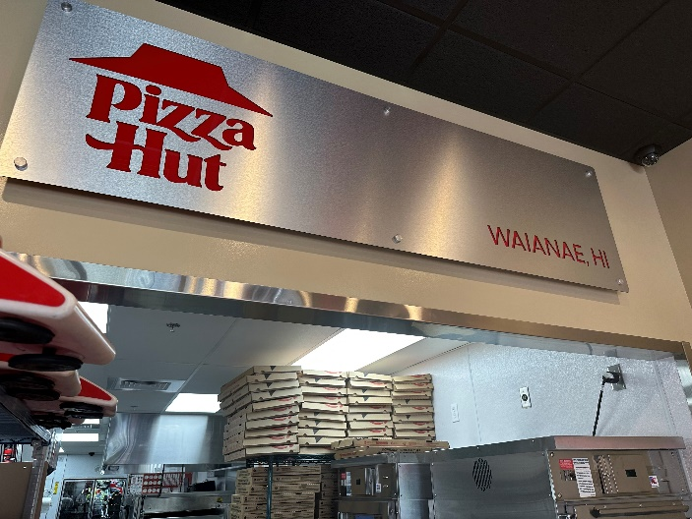
On May 24, Pizza Hut Hawaii opened its new location at Waianae Mall Shopping Center. This new storefront is located next to Bank of Hawaii at 86-120 Farrington Highway, Suite C303A and is the relocation of Pizza Hut Waianae.
Order online at pizzahut.com or by calling (808) 643-1111. Save time by ordering ahead through the Pizza Hut Mobile App and enroll in the Hut Rewards to earn points on all purchases. Rewards can be used for free pizzas and more.

