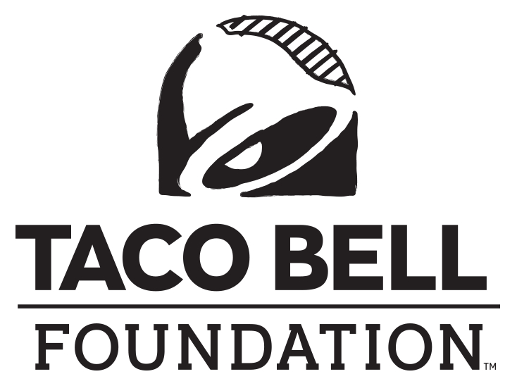

FOR IMMEDIATE RELEASE

Contact: Sydney Cerri
Becker Communications, Inc.
sydney@beckercommunications.com

COMMUNITY NONPROFITS AWARDED GRANT
TO fuel HAWAII’S YOUNG PEOPLE’s bold ambitions

HONOLULU (May 25, 2023) – Today, two non-profit organizations in Hawaii, Boys & Girls Club of Hawaii and Junior Achievement of Hawaii, received grants from the Taco Bell Foundation. Boys & Girls Club of Hawaii received a $15,000 grant and Junior Achievement of Hawaii received a $10,810 grant. These grants will support more than 10,000 youth in local communities. The funds will go toward character and leadership development, education and career development, health and life skills and other programs that educate and inspire the next generation of leaders.

“It’s a privilege to partner with the Taco Bell Foundation in educating and inspiring young people nationwide,” said Kevin Kurihara, CEO of TD Food Group, Inc. “Together, we are working to break down barriers to education for future leaders.”

Boys & Girls Club of Hawaii and Junior Achievement of Hawaii are two of more than 400+ youth-serving organizations that will receive a portion of the $15 million in Community Grants presented by the Taco Bell Foundation this year. The grants are an example of the Taco Bell Foundation’s mission to break down barriers to education and fuel young people’s boldest ambitions.

“We are proud that the work we do through our Community Grants program connects young people with the resources and opportunities they need to learn and drive change,” said Jennifer Bradbury, Executive Director of the Taco Bell Foundation.

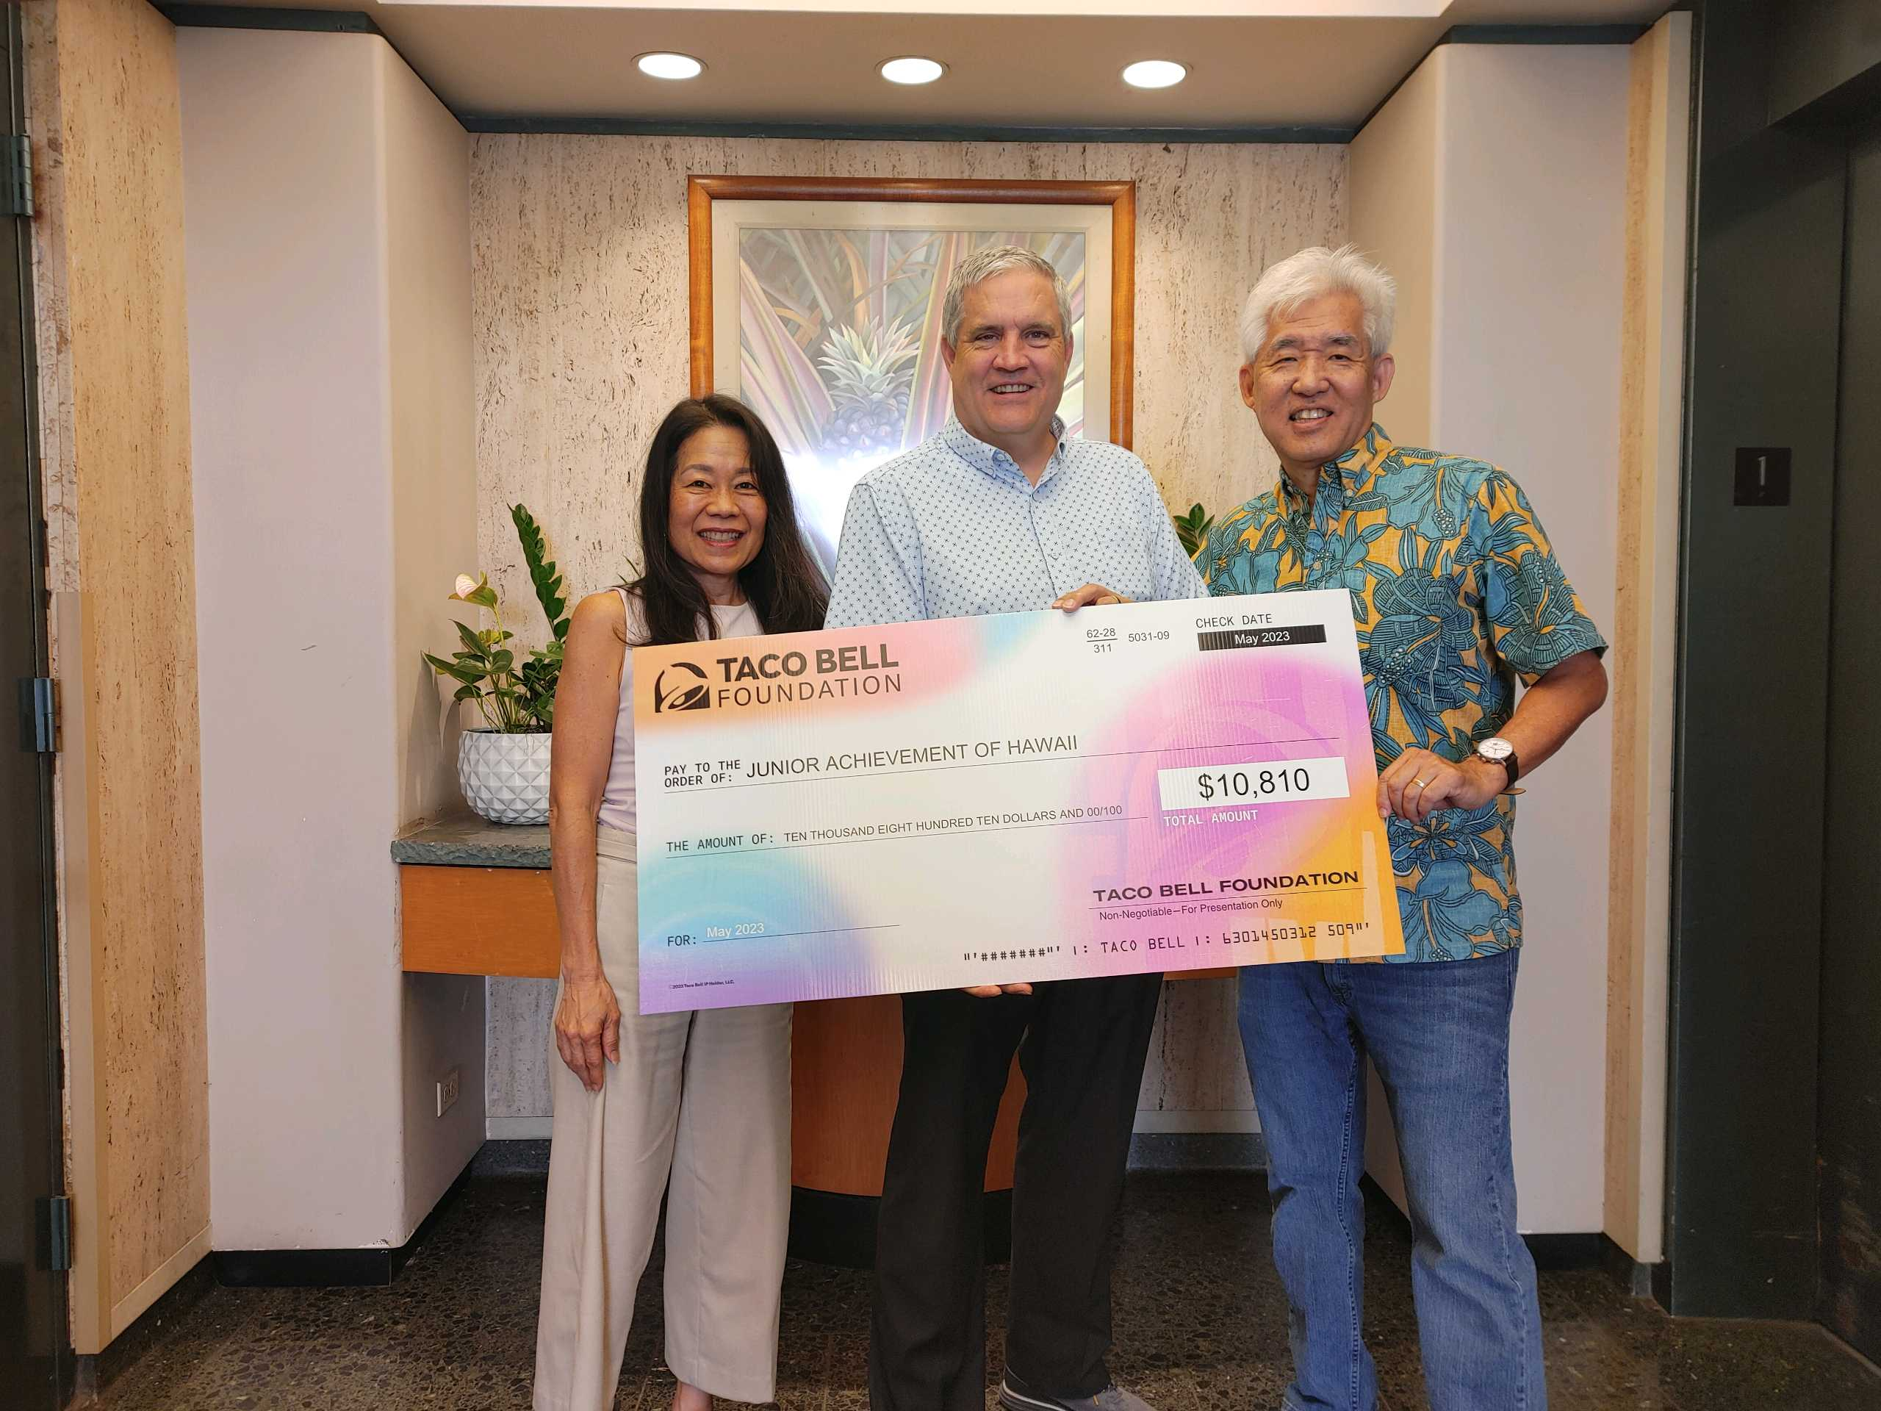
Check presentation to Junior Achievement of Hawaii pictured from L to R: Leah Allen, Director of Marketing, TD Food Group, Inc.; David Earles, President and CEO, Junior Achievement of Hawaii; and Brent Matsumoto, CFO, TD Food Group, Inc.
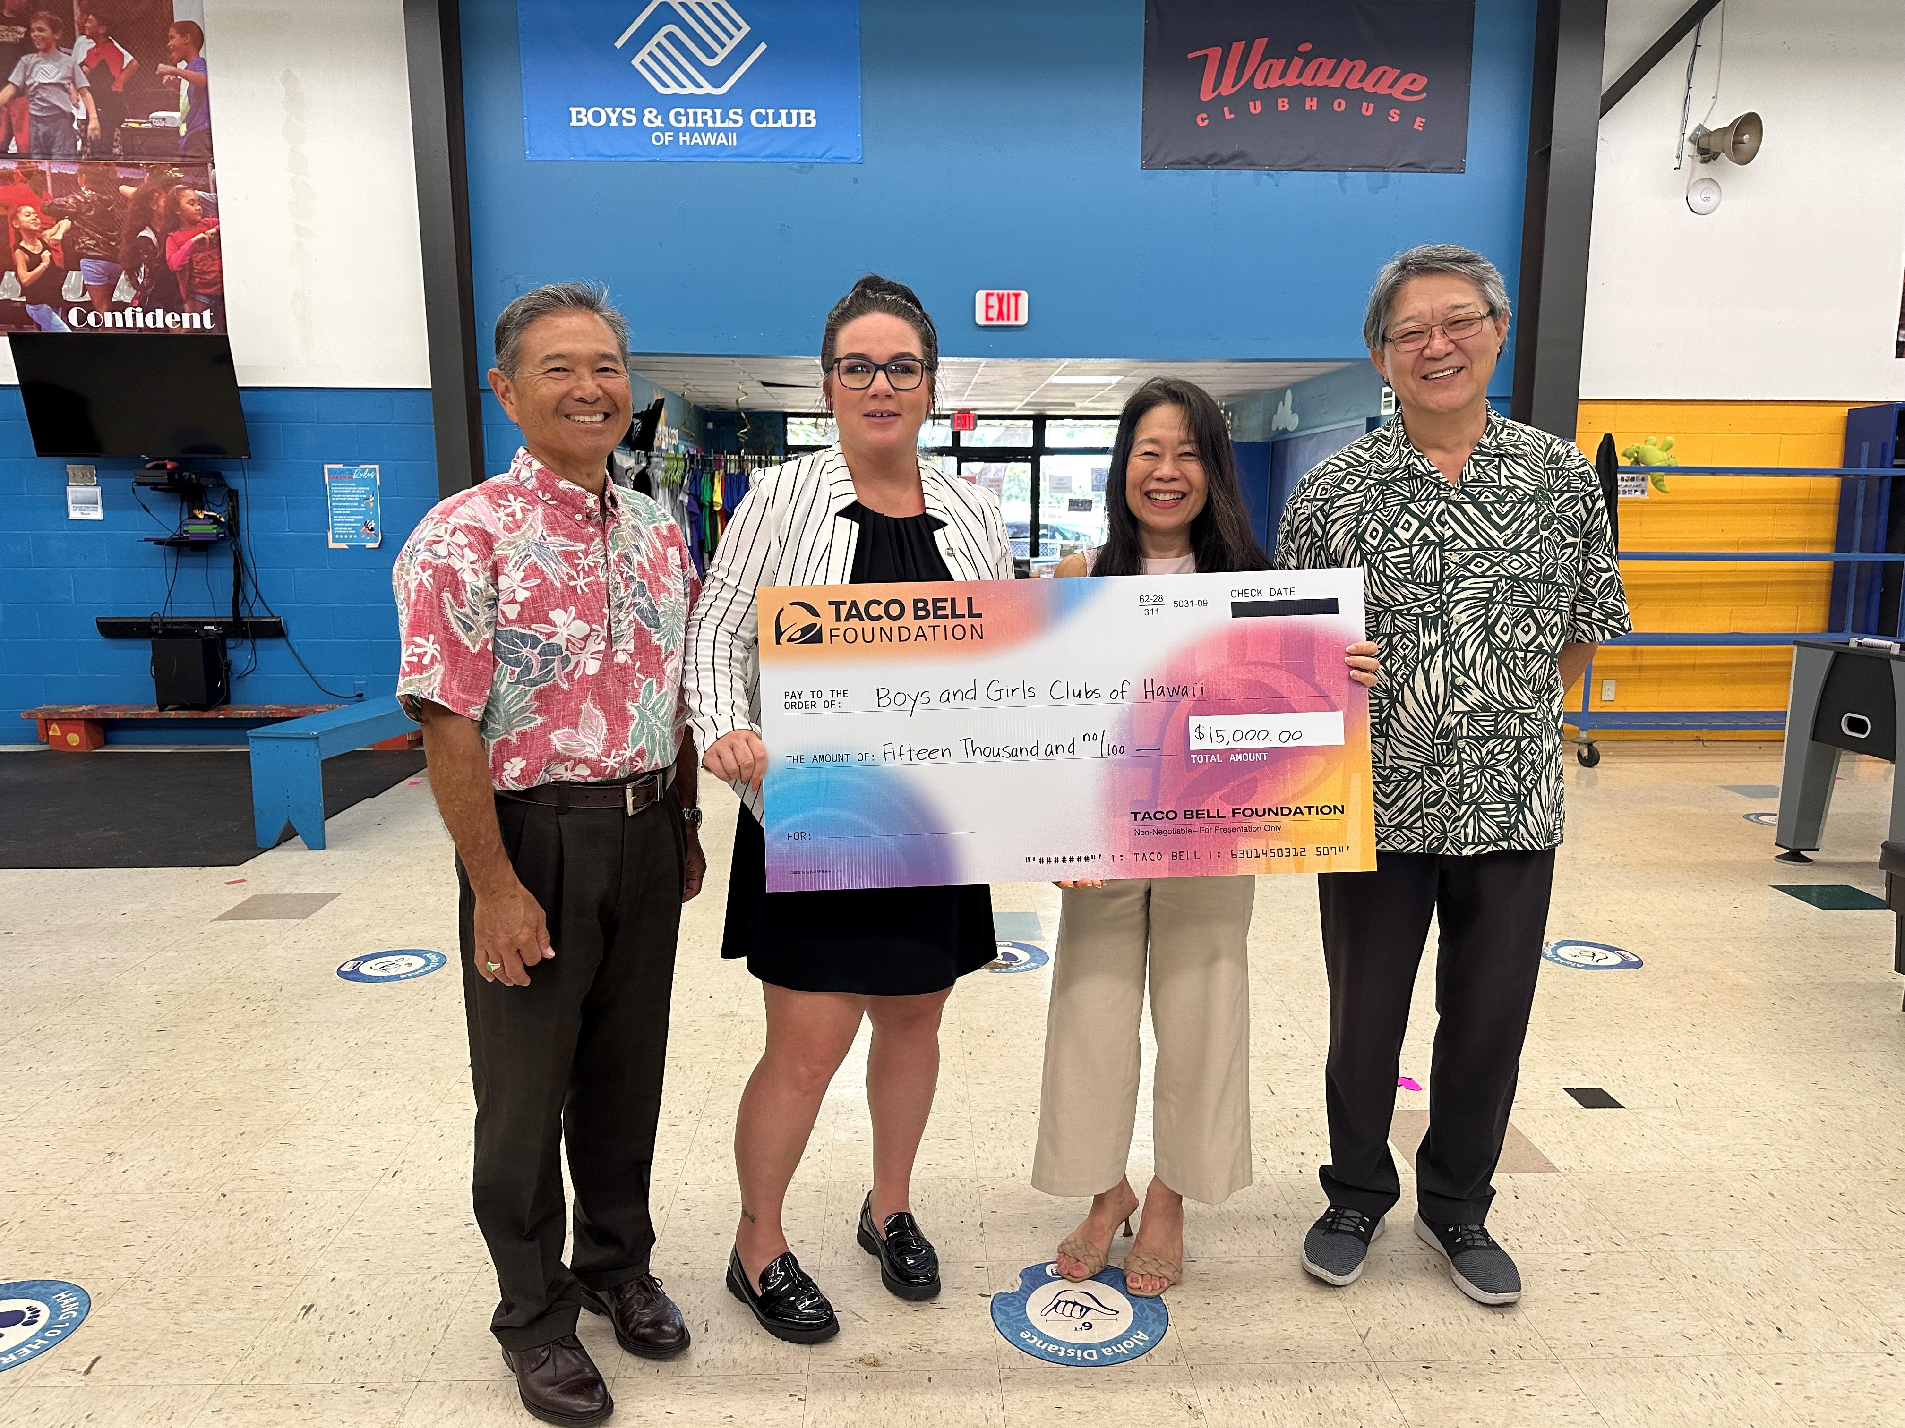
Check presentation to Boys & Girls Club of Hawaii pictured from L to R: Kevin Kurihara, CEO, TD Food Group, Inc.; Inglish Jones, Director of Development, Boys & Girls Club of Hawaii; Leah Allen, Director of Marketing, TD Food Group, Inc.; and Yong Min Kim, Director of Operations, TD Food Group, Inc.
About the Taco Bell Foundation
Taco Bell Foundation, Inc. is a 501(c)(3) tax-exempt public charity that educates and inspires the next generation of leaders through programming like the Live Más Scholarship and the Local Grants Program. Since 1992, the Taco Bell Foundation has reached more than 5 million young people across the country and has awarded more than $150 million in grants and scholarships, focused on education and career readiness. In 2015, Taco Bell and the Taco Bell Foundation launched the Live Más Scholarship, a program aimed at fueling the bold ambitions of America’s future leaders. In May 2023, the Taco Bell Foundation awarded $10 million in Live Más Scholarships to over 900 students. For more information, visit TacoBellFoundation.org.

About TD Food Group

TD Food Group operates 61 Pizza Hut and Taco Bell restaurants throughout the Hawaiian Islands and 13 Pizza Hut and Taco Bell restaurants in Guam and Saipan.

###

